

**BC3409 - AI in Accounting & Finance**

**Group Project Report**

Instructor: Professor Teoh Teik Toe

Group Number: 5

|  |  |
| --- | --- |
| **Name** | **Matriculation Number** |
| Brent Kuan Jia Yu | U1921095L |
| Ericson Thiang Soon Yao | U1710410F |
| Lim Jia Zheng Terence | U1710207F |
| Lim Yu Bin | U1810648F |
| Soo Xin Yang | U1922987D |
| Yu Ying Cheng | U1920016D |

**Table of Contents**

[**Executive Summary** 3](bookmark://_Toc56704913#_Toc56704913)

[**1** **Problem Analysis** 4](bookmark://_Toc56704914#_Toc56704914)

[1.1 Problem Statement 4](bookmark://_Toc56704915#_Toc56704915)

[1.2 Opportunities to Tackle the Problem 5](bookmark://_Toc56704916#_Toc56704916)

[**2** **Data Set** 8](bookmark://_Toc56704917#_Toc56704917)

[2.1 Data Exploration 8](bookmark://_Toc56704918#_Toc56704918)

[2.2 Data Visualisation 10](bookmark://_Toc56704919#_Toc56704919)

[2.3 Data Cleaning 13](bookmark://_Toc56704920#_Toc56704920)

[2.3.1 Min-Max Normalization 13](bookmark://_Toc56704921#_Toc56704921)

[2.3.2 Dropping of Time Feature from Dataset 14](bookmark://_Toc56704922#_Toc56704922)

[**3** **Modelling** 15](bookmark://_Toc56704923#_Toc56704923)

[3.1 Logistic Regression 15](bookmark://_Toc56704924#_Toc56704924)

[3.2 Decision Tree 16](bookmark://_Toc56704925#_Toc56704925)

[3.3 Neural Network 19](bookmark://_Toc56704926#_Toc56704926)

[**4** **Evaluation & Application** 20](bookmark://_Toc56704927#_Toc56704927)

[4.1 Evaluation & Insights 20](bookmark://_Toc56704928#_Toc56704928)

[4.2 Application of Results 21](bookmark://_Toc56704929#_Toc56704929)

[4.3 Limitations of Project 22](bookmark://_Toc56704930#_Toc56704930)

[**5** **Conclusion & Future Studies** 24](bookmark://_Toc56704931#_Toc56704931)

[**6** **References** 26](bookmark://_Toc56704932#_Toc56704932)

# **Executive Summary**

Heart Failure is an illness that affects 40 million people globally. The condition causes its victim’s heart to be unable to pump blood sufficiently to maintain the body’s regular functions. Heart Failure is often a fatal disease with mortality rates, up to 60%, within 5 years of diagnosis. The illness has often been coined both as a “Public Health Burden” and an “Economic Burden” due to its increasing prevalence among ageing populations and its heavy drain on societal resources.

In view of this adversity, many clinical research and technological innovations have been directed towards the study of heart failure, to derive ways to prevent and alleviate the problem. Likewise, in this project, we aim to utilize Machine Learning techniques to predict mortality of heart failure patients and identify relationships between patient traits and terminal heart failure.

In the following report, our team demonstrated the use of Machine Learning through an analysis of a clinical record dataset of 299 heart failure patients. The dataset comprises of information on the patients’ biodata, health behavior, diseases, laboratory measures and survival status. We applied 3 distinct machine learning algorithms – Logistic Regression, Decision Tree and Neural Network to predict the mortality of heart failure patients based on pre-existing traits available in clinical records. Our results demonstrated that Machine Learning can be effectively used in the prediction of survivability among heart failure patients and revealed underlying features that may lead to fatal heart failure.

There are many opportunities for future studies to expand on this project, both in scope and depth. Currently, it serves as a proof-of-concept of the application of Machine Learning in treatment of medical diseases. We hope that the project will spur greater adoption of these techniques within the healthcare industry, to alleviate the burdens of our society.

# **Problem Analysis**

## Problem Statement

**What is Heart Failure?**

Heart Failure, also known as Congestive Heart Failure (CHF), is a chronic and progressive condition where the heart muscle is unable to pump enough blood to meet the body’s need for blood and oxygen. As the heart struggles to supply enough oxygen, blood vessels narrow to keep the blood pressure up and make up for the difference [1]. Blood is also diverted away from less important tissues and organs, to the heart and the brain, leading to possibility of organ failure as well. As the heart’s performance continues to decline, it reaches a final stage “Class IV” where there is no cure left to treat the patient and they are left with options to maintain quality-of-life before facing death [2]. The fatality rate of Heart Failure is estimated to be around 20% after being diagnosed in the first year [3].

**Prevalence of Heart Failure in Aging Populations**

Heart Failure is a common problem, affecting almost 40 million people globally [1]. The condition impacts elderly disproportionately, with three to five times more prevalence for those age above 65 years old [4]. Given the projected rise in elderly population, it is very likely to see a greater number in Heart Failure occurrence globally [5].

**Motivation for Our Study**

Several studies on patients’ medical records have been conducted using Machine Learning (ML) to identify Heart Diseases, for example, the study of cardiac imaging and cardiovascular diseases [6]. In the area of Heart Failure, a study was conducted on the survival analysis of Heart Failure patients from Pakistan using Cox regression [7]. From a clinical perspective, accurate prediction of fatality from Heart Failure could be useful for clinical doctors in making more informed diagnoses. Besides, understanding the causal factors of mortality would help doctors prescribe treatments that could save a patient’s life. In our study, we find that there is room for us to use ML techniques to increase the accuracy of the predictions and identify key features that could contribute to the fatality rate.

## Opportunities to Tackle the Problem

With advancements in technology increasing processing capabilities of computers, machine learning has grown increasingly popular and seen adoption across multiple fields. This is evident as the Machine Learning Market is projected to reach $117.19 Billion by 2027 [8], as its uses expand from areas like categorical prediction to self-driving capabilities. Industry norms are disrupted by this change and the healthcare industry is no different. A report by Business Insider Intelligence [9] found that spending on Artificial Intelligence (AI) in healthcare, is projected to grow at an annualized rate of 48% between 2017 and 2023. It shows that more and more companies within the healthcare sector are becoming increasingly receptive to the adoption of AI and ML.

*Figure* 1 *- Road Map for Clinical Data Generation in Jiang's study* [10]

This is also supported by Jiang’s study [10], which highlighted how the advent of AI in healthcare resulted in a “paradigm shift” and it is further fueled by the increasing availability of healthcare data and rapid progress of analytic techniques. One important trend within the adoption of AI in healthcare is the use of data-driven clinical decision support (CDS), where machines use algorithms and data to identify patterns and produce automated insights to healthcare providers, helping them with the diagnosis process. This reduces the diagnostic and therapeutic errors that are inevitable in the human clinical practice by providing an unbiased analysis based on data.

An example of such application of AI in the field of healthcare is the use of IBM Watson in cancer treatment [11]. The system utilized ML and Natural Language Processing (NLP) modules to address challenges in oncology. The model has shown to be successful, its identification and recommended treatment for cancer was 99% coherent with that of a physician’s decision [10]. The model even managed to identify a rare form of Leukemia in an instance in Japan [10].

Taking this in relation to our project, this presents an opportunity to utilize ML to address the issue of early identification of heart failure. It is possible to develop such a model as there exist both research [12] and data [13], on the potential factors contributing to the development of heart failure. For example, the symptoms of heart failure are well documented ranging from signs like fatigue, palpitations, and even shortness of breath [14]. This can serve as possible identifiers of heart failure if observed. Furthermore, there are other conditions that have found to increase the likelihood of heart failure. These conditions include coronary artery disease, high blood pressure, valvular heart disease etc. [15]. Lastly, lifestyle habits as well as individual characteristics like smoking or age are also factors that can assess a patient’s likelihood of heart failure [15]. Although these factors are known to be possible contributing factors to heart failure, the exact feature importance they have on heart failure is not known. Thus, there is value in conducting machine learning to identify this gap in knowledge.

As it is established that there exist possible factors that contribute to the development of heart failure, this presents a clear opportunity to develop a machine learning model to establish the patterns between such features and likelihood of death from heart failure. This allows us to both identify a patient’s likelihood to suffer from heart failure as well as the likelihood for him to succumb to heart failure. With the ability for such early identification, we are hence able to provide treatment in the early stages of heart failure thereby increasing the patient’s likelihood for survival while reducing the complexity of treatment. Our model will also allow us to identify the importance of identified features as determinants of heart failure and thus allow medical practitioners to pay special attention on such attributes and advice their patients accordingly. The culmination of both benefits from our machine learning model would thereby be invaluable in humanity’s fight against heart failure.

# **Data Set**

The *heart_failure_clinical_records* dataset [7] consists of 299 records of patients with heart failure and their survival status from the illness. The dataset includes 12 features consisting of the patients’ biodata, health behavior, clinical diagnosis of diseases, clinical and laboratory measures; and 1 feature on *DEATH_EVENT*, which represents the status of the patient after heart failure. The description of all the variables and coded data values can be found in the data dictionary document.

## Data Exploration

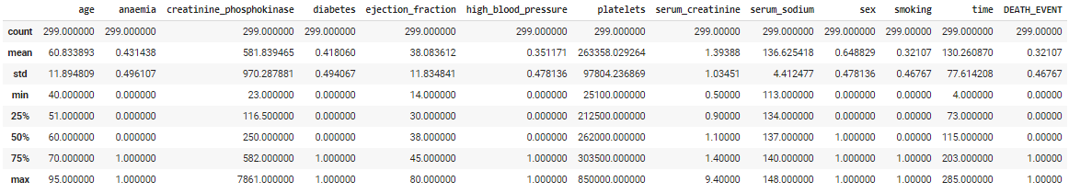

Figure 2 - Descriptive Statistics of Dataset

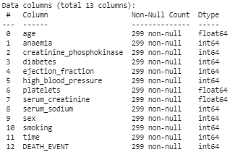

Figure 3 - Null Values

The descriptive statistics (Figure 2) reveals that 96 out of 299 patients or 32%, died after being diagnosed with heart failure. The patients are in their mid to late stages of their lives, between age 40 to 95, with a median age of 60 years old. The dataset consists of a larger proportion of male (64%) to female (36%) patients and it shows that 32% of the patients partake in smoking. With regards to diagnosis of diseases, 4% of patients are diagnosed with anemia, 42% of patients have diabetes and 35% suffer from high blood pressure. There are no null values for all columns within the dataset (Figure 3).

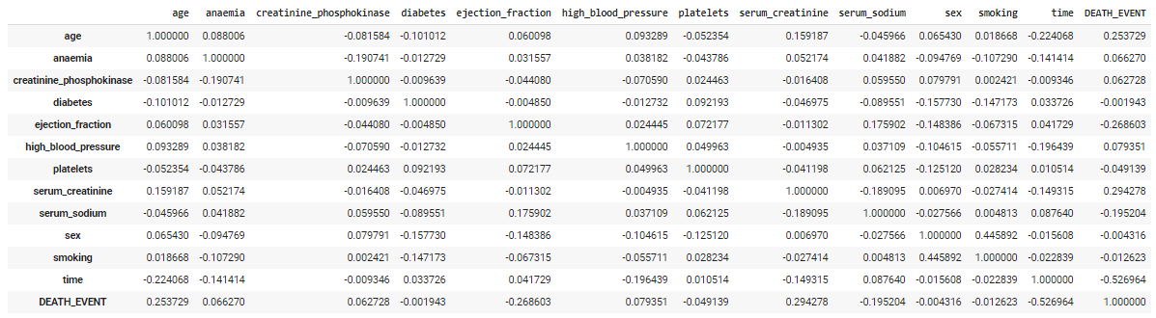

Figure 4 - Correlation Table of Dataset

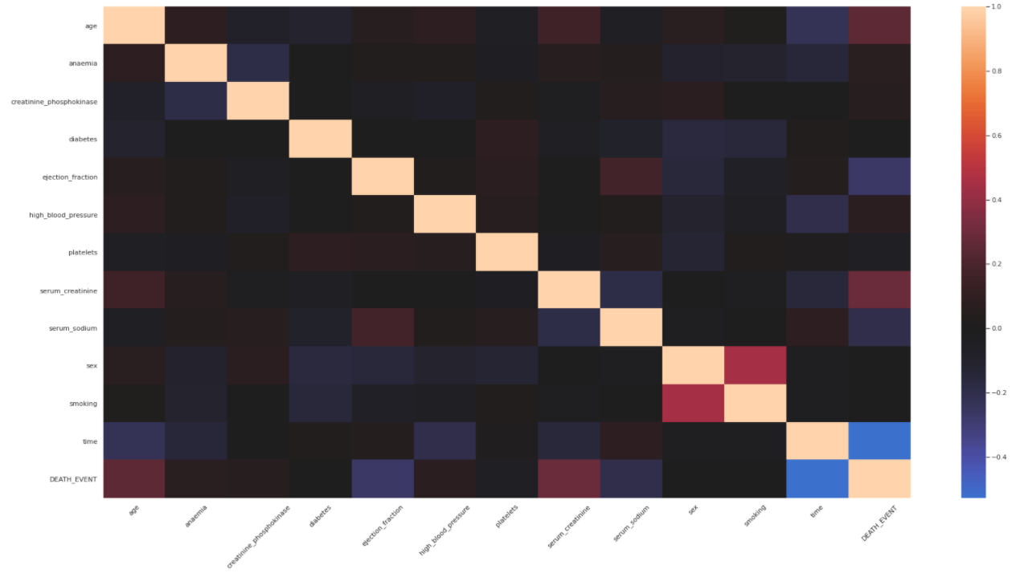

Figure 5 - Correlation Heatmap of Dataset

The correlation table (Figure 4) and heatmap (Figure 5) reveals a strong correlation (-0.526) between our y-variable, *DEATH_EVENT*, and *time*. Other features that correlates weakly with *DEATH_EVENT*, includes *age* (0.253), *serum_creatinine* (0.294) and *ejection_fraction* (-0.268). Lastly, there are no signs of strong multicollinearity between the other x-variables.

## Data Visualisation

The data visualisation is done on the R script, where we analysed various features and their association with *DEATH_EVENT*.

1. **AGE**

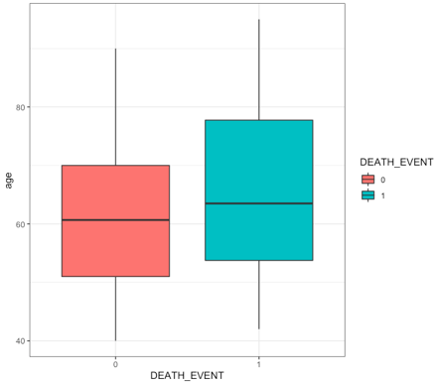The boxplot in Figure 6 shows that the age distribution for patients who died from heart failure is higher than those who survived. Hence, in general, patients who are older have a greater likelihood of mortality from heart failure.

Figure 6 – Boxplot of Age by DEATH_EVENT

1. **SEX**

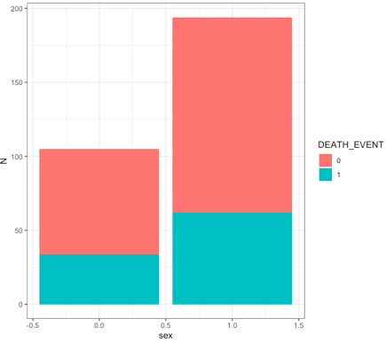We can gather from Figure 7 that there is no significance difference in the likelihood of mortality from heart failure when comparing between male and female patients.

Figure 7 - Barplot of Sex & DEATH_EVENT

1. **HIGH BLOOD PRESSURE**

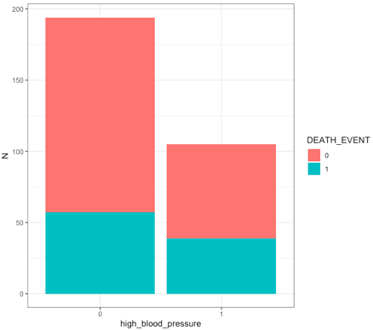From Figure 8, we can identify that there is a slightly higher likelihood of mortality from heart failure among patients who suffer from high blood pressure.

Figure 8 - Barplot of high_blood_pressure & DEATH_EVENT

1. 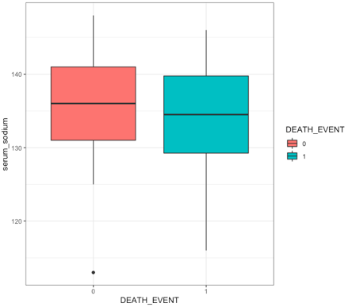**SERUM SODIUM**

The boxplot in Figure 9 indicates a lower distribution of *serum_sodium* levels correlates to higher mortality rate among patients with heart failure. Generally, patients with lower *serum_sodium* levels are more likely to die after diagnosis.

Figure 9 - Boxplot of serum_sodium by DEATH_EVENT

1. **CREATININE PHOSPHOKINASE**

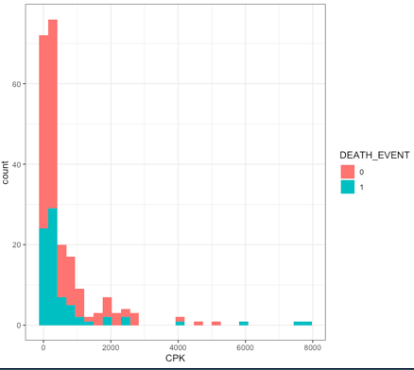The histogram in Figure 10 shows that patients with high levels of *creatinine_phosphokinase* have greater likelihood of mortality from heart failure.

Figure 10 - Histogram of creatinine_phosphokinase by DEATH_EVENT

1. **EJECTION FRACTION**

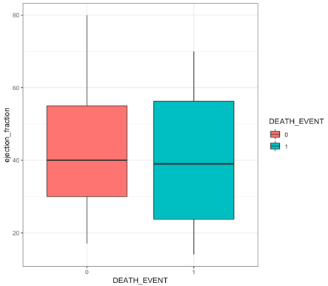From Figure 11, we can observe that patients with lower *ejection_fraction* levels demonstrate greater likelihood of mortality from heart failure.

Figure 11 - Boxplot of ejection_fraction by DEATH_EVENT

1. **SERUM CREATININE**

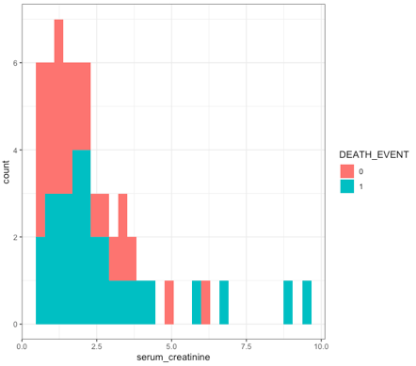From our observations of Figure 12, we can derive that patients with higher levels of *serum_creatinine* had higher likelihood of mortality from heart failure.

Figure 11 – Histogram of serum_creatinine by DEATH_EVENT

## Data Cleaning

Within the dataset, there are no null values to handle and there is no issue with multicollinearity between the input variables. Before passing the dataset into our models, we decided to normalize using min-max normalization.

### Min-Max Normalization

The formula for min-max normalization is shown as:

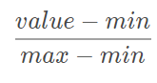

Min-max normalization is one of the most common ways to normalize data. For every independent variable, the minimum value of that feature will be taken as 0, and the maximum or highest value will be taken as 1. All other values will be scaled proportionately to a decimal between 0 and 1.

### Dropping of Time Feature from Dataset

Given that the *time* variable in this data set refers to the follow up period of the patient after the first visit, we have deemed it to be largely irrelevant to our training model. From the data exploration (Section 2.2), the *time* feature has a relatively high negative correlation (-0.526) with the y-variable, *DEATH_EVENT*, which demonstrates a relationship between both features. On further consideration, we noted that patients who died will not be able to pay a second visit to the hospital, hence, a shorter *time* will imply a higher possibility of death. For future predictions we do not have the foresight to determine the follow up period of each patient. Thus, we decided that it will be logical and beneficial to remove the *time* feature from the computation and training of our prediction models.

# **Modelling**

## Logistic Regression

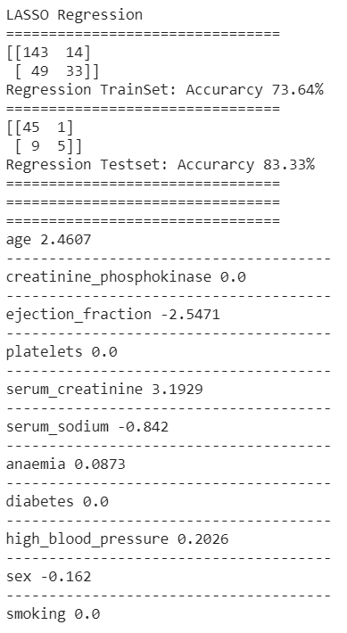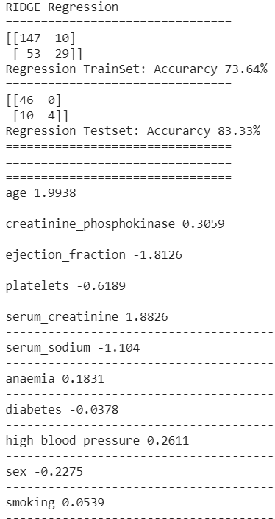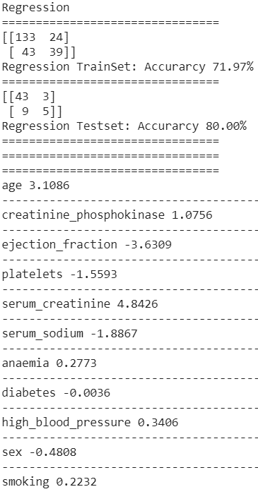

Figure 13 - Performance of Logistic Regression Models

For the prediction of mortality in heart failure patients, we first applied 3 logistic regression models to the min-max normalised dataset. The accuracy of the 2 logistic regression models with regularization slightly edges above the model without. Looking at the coefficients of the Lasso Regression model (Figure 14), the strongest contributing features are *serum_creatinine, ejection_fraction* and *age*. This is supported by the correlation matrix (Figure 3), where these variables have the highest correlation coefficient as well. As seen from the Lasso Regression results, the coefficient of several variables (*creatinine_phosphokinase, platelets, diabetes,* and *smoking*) are reduced to zero during the regularization process. Hence it is likely that these variables have little impact to patient mortality.

## Decision Tree

The next model we built was a Decision Tree Classifier which is a supervised learning method that predicts the value of a target with decision rules inferred from the data features [16]. The Decision Tree model does not require the use of min-max normalised data for training, normalization does not affect the impurity function in determining the splits. Using the default parameter of Scikit-learn Decision Tree Classifier, we achieved a test-set accuracy of 71.67%. However, the default tree has likely overfit as implied by the 100% training accuracy and the settings which does not penalize the tree from overgrowing.

Figure 14 - Full Decision Tree with Default Parameters

We performed GridsearchCV with 10-fold cross validation across the parameters, *max_depth*, *minimum_samples_split* and *min_impurity_decrease* which controls the tree growth. Meanwhile, we also controlled *ccp_alpha* on a separate test to find the model that is less likely to overfit.

|  |  |  |  |
| --- | --- | --- | --- |
| **Grid Search Tuning** | | | |
| **Trainset Accuracy** | | 79.09% | |
| **Testset Accuracy** | | 63.33% | |
| **DEATH_EVENT** | | **Actual** | |
| 0 | 1 |
| **Predicted** | 0 | 31 | 14 |
| 1 | 8 | 7 |

Table 1 - Grid Search Tuned Decision Tree Model Performance

Using the best parameters from GridsearchCV, the accuracy was lowered to 63.33% on testset versus the default model of 71.67%

Figure 15 - Decision Tree Accuracy with different ccp_alphas

|  |  |  |  |
| --- | --- | --- | --- |
| **ccp_alphas Tuning** | | | |
| **Trainset Accuracy** | | 88.70% | |
| **Testset Accuracy** | | 73.33% | |
| **DEATH_EVENT** | | **Actual** | |
| 0 | 1 |
| **Predicted** | 0 | 31 | 8 |
| 1 | 8 | 13 |

Table 2 - ccp_alpha Tuned Decision Tree Model Performance

Separately, after controlling for *ccp_alphas*, we found that setting *ccp_alpha* = 0.00892608 achieved improved testset result of 73.33%, as compared to Gridsearch tuning of 63.33% and default model of 71.67%.

Figure 16 - ccp_alpha Tuned Decision Tree visualized

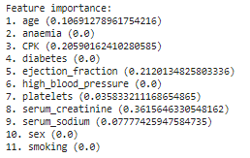

Figure 17 – Feature Importance of ccp_alphas Tuned Decision Tree

The important features highlighted from the ccp_alpha Tuned Decision Tree are *serum_creatinine* (0.362)*, ejection_fraction* (0.212)*, creatinine_phosphokinase (CPK)* (0.205)and *age* (0.106).

## Neural Network

|  |  |  |  |
| --- | --- | --- | --- |
| **Neural Network** | | | |
| **Trainset Accuracy** | | 91.63% | |
| **Testset Accuracy** | | 88.33% | |
| **DEATH_EVENT** | | **Actual** | |
| 0 | 1 |
| **Predicted** | 0 | 43 | 2 |
| 1 | 5 | 10 |

*Figure 18: Neural Network Model Performance*

Lastly, we developed a Neural Network model using the Sequential model from Keras, on the min-max normalised dataset. After tuning the hyperparameters, the model had a testset accuracy of 88.33%, as shown in Figure 18. We are unable to identify the feature importance for the Neural Network model.

# **Evaluation & Application**

## Evaluation & Insights

|  |  |  |  |
| --- | --- | --- | --- |
| **Model** | **Lasso Logistic Regression** | **Decision Tree** | **Neural Network** |
| Confusion Matrix |  |  |  |
| Testset Accuracy | 83.33% | 73.33% | 88.33% |
| Recall  TP / TP + FN | 83.33% | 61.90% | 83.33% |
| Important Features | serum_creatinine  ejection_fraction  age | serum_creatinine  ejection_fraction  creatinine_phosphokinase  age |  |

Figure 19 – Results of Prediction Models

Overall, across the different models we implemented, we achieved a peak accuracy on classification of 88.33% from the Neural Network model with min-max normalization of the dataset.

In predicting health condition of patients, and even more so for mortality prediction, it is crucial to avoid False Negatives which indicates a patient who is going to die but was predicted not to. This is due to obvious reasons as the consequences for such events would be dire. A False Negative prediction would lead healthcare professionals and patients to have an inaccurate diagnosis on his life expectancy and therefore neglect the need for treatment to address this. As such, this could lead to the patient’s death, despite being preventable, as well as causing the patient to not conduct himself as he would have if he was aware of his mortality. As such, it is crucial for us to consider the False Negatives predicted by our model. As seen in Figure 19, which presents the confusion matrix, our Neural Network model predicted 2 False Negatives giving it the highest recall score of 83.33%, along with Lasso Regression model. Recall measures the ability of the model to correctly identify all the positive cases. This implies that out of all mortality cases, the model can accurately identify them 88.33% of the time. The model can be further improved by being “over-sensitive” in predicting positive cases to ensure that every patient that will potentially die from heart failure is identified. This would mean that the model would compromise on precision to achieve greater recall. It is acceptable to make this compromise as False Positives would mean that the patients merely receive greater monitoring as well as treatment and is unlikely to be a life-threatening trade-off.

The model results also highlighted important features in the prediction of mortality in patients with heart failure. Across the models, the common features highlighted were *serum_creatinine, ejection_fraction* and *age*.

## Application of Results

Our project has demonstrated the possible applications of Machine Learning techniques to predict mortality and identify important predictive traits of heart failure patients. Prediction of mortality can support doctors in their evaluation of patient’s survivability and life expectancy after diagnosis of heart failure. As compared to evaluations by medical professionals, our model output does not have any human bias. In Clarke’s study [17] , which focuses on medical professionals’ accuracy in predicting life expectancy, he found that professionals had a high tendency to underestimate the life expectancy of their patients. Doctors, nurses and medical students underestimated the life expectancy in 62%, 64% and 66% of cases respectively. This inability to accurate predict life expectancy is so severe that the differences in prediction and actuality deviated by an overestimation of 700% in some instances. It is found that healthcare professionals would under/overestimate the life expectancy by 25% (1 year for a life expectancy of 4 years). Furthermore, this accuracy is likely due to human biases as oppose to lack of experience. This is evident as doctors were as inconsistent and inaccurate when compared to medical students despite their increased experience and knowledge. As such, given that the current predictions for life expectancy and mortality by doctors are found to be unreliable and inaccurate, our model can provide further statistical validation to the evaluations of these professionals. Moreover, our model can derive mortality prediction immediately once the relevant patient data is available, with a high accuracy of 88.33%. In view of the limited time these patients have, ML allows for quick, veracious diagnosis on mortality of patients with heart failure.

Additionally, the prediction models can help medical researchers uncover the underlying mechanisms leading to heart failure. Researchers can focus on the critical features that predict fatal heart failures and investigate the implicit relations these features have on the severity of the illness. The Decision Tree model, with splits along the values of features selected, may also highlight thresholds that could serve as guidelines between the boundaries of terminal heart failure. These findings can help researcher identify the hidden causes of severe heart failure and provide medical practitioners with key indicators to look out for in their patients. Hence, improving treatment and prevention of heart failures within our community.

## Limitations of Project

The dataset [7] we used for this project is rather small (299 patients), with limited number of recorded patient traits (11 features excluding *time*). The dataset might not be a sufficient sample to represent the overall population of patients with Heart Failure. A larger dataset might be better to improve the reliability of our predictive models [18] as they account for a more diverse dataset. Also, the traits recorded were limited to a few of the patient’s behavioral traits, diagnosis of diseases and clinical measures, there may be several other factors like occupation [19] that could possibly influence a patient’s mortality rate from heart failure. Saying that, the main focus of the project is to demonstrate the use of ML, hence, the veracity of the results obtained is not critical.

Another limitation of the project is that the predicted variable is *DEATH_EVENT*, which indicates the survivability of the patient diagnosed with Heart Failure. Although this is somewhat useful in supporting health practitioners in their evaluation on the severity of the illness and life expectancy of the patient, a more useful predictive variable might be the remaining lifespan of the patient after diagnosis. However, this alternative also comes with its limitations, it would require finding an appropriate dataset: with lifespan as a feature and a much larger sample size for adequate prediction of a continuous variable. Moreover, the accuracy of the predictive models might be an issue and there is a need to consider skewed data as patients who survive will be registered with extremely high lifespans. Having said that, prediction of the life expectancy of patients with Heart Failure has a lot of practical value for health practitioners and it is worth exploring in future studies.

# **Conclusion & Future Studies**

Our project has demonstrated the possible applications of Machine Learning techniques to help medical professionals, in their understanding, diagnosis and prescription with regards to fatal heart failures. The results from this project serve as a proof-of-concept that ML and AI can be leveraged as tools to help tackle the clinical burden of heart failure present within our society.

Besides what was demonstrated, there are many other ways to expand on the scope and depth of our project. Specifically, for diagnosis of patients, instead of simply predicting mortality from heart failure, subsequent research can investigate the prediction of the remaining lifespan of patients from initial diagnosis. This can better assist healthcare professionals to provide more accurate, unbiased estimates on life expectancy, allowing patients to better plan their remaining time. As for prevention of heart failure, to better understand the features that cause the development of heart failure, we can perform predictions on heart failure occurrence instead of mortality from heart failure. The dataset will expand to include those with and without heart failure. The results will allow us to identify patient traits that directly lead to heart failure.

Lastly, we can increase the size of the data, by increasing the number of features and the number of patients, so that a more comprehensive analysis can be done. The data pool can be established through collection of medical records across various hospitals and healthcare facilities globally. The datasets extracted for modelling may be segmented by countries, as cultural and lifestyle differences might affect the development of heart failure in people. With the expanded data, the same machine learning techniques can be applied to give a more complete and accurate investigation of the causal factors of heart failure and predict heart failure susceptibility among the general population.

With this project and future developments, we hope that it will spur greater adoption of Machine Learning and Artificial Intelligence in the healthcare field and improve our chances against critical illnesses that plague humanity.

# **References**

|  |  |
| --- | --- |
| [1] | NHLBI, "National Heart, Lungs and Blood Institute," 1 November 2020. [Online]. Available: https://www.nhlbi.nih.gov/health-topics/heart-failure#:~:text=Heart%20failure%20is%20a%20very,the%20symptoms%20and%20treatments%20differ.. |
| [2] | Healthline, "Healthline," 21 February 2019. [Online]. Available: https://www.healthline.com/health/congestive-heart-failure#types. |
| [3] | C. J. Taylor , R. F. D. Hobbs and T. Marshall, "Trends in survival after a diagnosis of heart failure in the United Kingdom 2000-2017: population based cohort study," *BMJ,* vol. 364, no. 223, 2019. |
| [4] | European Heart Journal, "European Heart Journal," 1 October 2008. [Online]. Available: https://academic.oup.com/eurheartj/article/29/19/2388/2398014. |
| [5] | S. Stewart, K. MacIntyre, S. Capewell and J. J. V. McMurray, "Heart failure and the aging population: an increasing burden in the 21st century?," *Heart,* vol. 89, no. 1, pp. 49-53, 2003. |
| [6] | S. J. Al'Aref and K. Anchouche, "Clinical applications of machine learning in cardiovascular disease and its relevance to cardiac imaging," 2019 June 21. [Online]. Available: https://pubmed.ncbi.nlm.nih.gov/30060039/. |
| [7] | T. Ahmad, A. Munir, S. H. Bhatti, M. Aftab and M. A. Raza, "Survival analysis of heart failure patients: A case study," *PLoS ONE,* vol. 12, no. 7, 2017. |
| [8] | FBI, "Machine Learning Market Size, Share & COVID-19 Impact Analysis, and Regional Forecast, 2020-2027," Fortune Business Insights, 2020. |
| [9] | A. Phaneuf, "AI in Medical Diagnosis," Business Insider Intelligence, 2019. |
| [10] | F. Jiang, Y. Jiang, H. Zhi, Y. Dong, L. Hao, S. Ma, Y. Wang, D. Qiang, H. Shen and Y. Wang, "Artificial intelligence in healthcare: past, present and future," *Stroke and Vascular Neurology,* vol. 2, no. 4, 2017. |
| [11] | S. P. Somashekhar, R. Kumarc, A. Rauthan, K. R. Arun, P. Patil and Y. E. Ramya, "Abstract S6-07: Double blinded validation study to assess performance of IBM artificial intelligence platform, Watson for oncology in comparison with Manipal multidisciplinary tumour board – First study of 638 breast cancer cases," *Cancer Research,* vol. 77, no. 4, 2017. |
| [12] | J. Wu, J. Roy and W. F. Stewart, "Prediction Modeling Using EHR Data: Challenges, Strategies, and a Comparison of Machine Learning Approaches," *Medical Care,* vol. 48, no. 6, pp. 106-113, 2010. |
| [13] | M.-a. G. G. i. C. H. F. (MAGGIC), "The survival of patients with heart failure with preserved or reduced left ventricular ejection fraction: an individual patient data meta-analysis," *European Heart Journal,* vol. 33, no. 14, pp. 1750-1757, 2012. |
| [14] | A. J. S. Coats, "What causes the symptoms of heart failure?," *Heart ,* vol. 86, no. 5, pp. 574-578, 2001. |
| [15] | P. Ponikowski, S. D. Anker, K. F. AlHabib, M. R. Cowie, T. L. Force, S. Hu, T. Jaarsma, H. Krum, R. Vishal, L. E. Rohde, U. C. Samal, H. Shimokawa, B. B. Siswanto, K. Sliwa and G. Filippatos, "Heart failure: preventing disease and death worldwide," *ESC Heart Failure,* vol. 1, no. 1, pp. 4-25, 2014. |
| [16] | Scikit-Learn, "Decision Trees," 1 November 2020. [Online]. Available: https://scikit-learn.org/stable/modules/tree.html#tree. |
| [17] | C. MG, E. P, H. T, D. L, G. T and W. AL, "How accurate are doctors, nurses and medical students at predicting life expectancy?," *European Journal of Internal Medicine,* vol. 20, no. 6, pp. 640-644, 2009. |
| [18] | D. Chicco and G. Jurman, "Machine learning can predict survival of patients with heart failure from serum creatinine and ejection fraction alone," *BMC medical informatics and decision making,* vol. 20, no. 1, p. 16, 2020. |
| [19] | K. Steenland, "Epidemiology of occupation and coronary heart disease: Research agenda," *American Journal of Industrial Medicine,* vol. 30, no. 4, pp. 495-499, 1996. |